 EAST WEST UNIVERSITY

Department of CSE

PROJECT Report

**Project Title:** Rental Management System

**Course Code:** CSE301

**Course Title:** Database Systems

**Section :** 04

**Group Members:** i) Rayhan Ahmed

ID: 2016-1-60-141

ii) Ananta Roy

ID:2016-1-60-108

**Submitted To:** Md. Mohsin Uddin

Lecturer, Department of CSE

**Date of Submission:** 13.12.18

**Problem Statement:**

In today’s world, everyone has to work full time to earn his or her livelihood. Therefore, it is not possible for an individual to dedicate him or her to find flats on suitable place at every time. That is why people are lying on rental agency so that they can have some time for themselves. It's really tough to find flats as one wants.Because of that, people have to wait in a queue to get flats and have to wait until the other tenant move somewhere else. Now, here comes the idea of the rental management system. To avoid these hurdles people can rent flats via online which is a convenient way.

**Summary of Our Project:**

We have provided an easily accessible interface in which the customers can easily view the flat. The tenants initially need to register themselves with minimum details and check the flat before renting and add them to the rent and submit . The system records details in the MySQL database to make it easy to retrieve later. The admin panel can add new information or delete already existed data and can update the list of the flat. They can also view rent history of the tenants.

**Entities and Its attributes:**

The main entities identified in the system are listed below :

Admin[Attributes-> username, password]

Tenants_details [Attributes -> name, floor, bill, phno, due]

Owners_details [Attributes -> oid, *tid*,tdate]

**Entity Relational Diagram:**

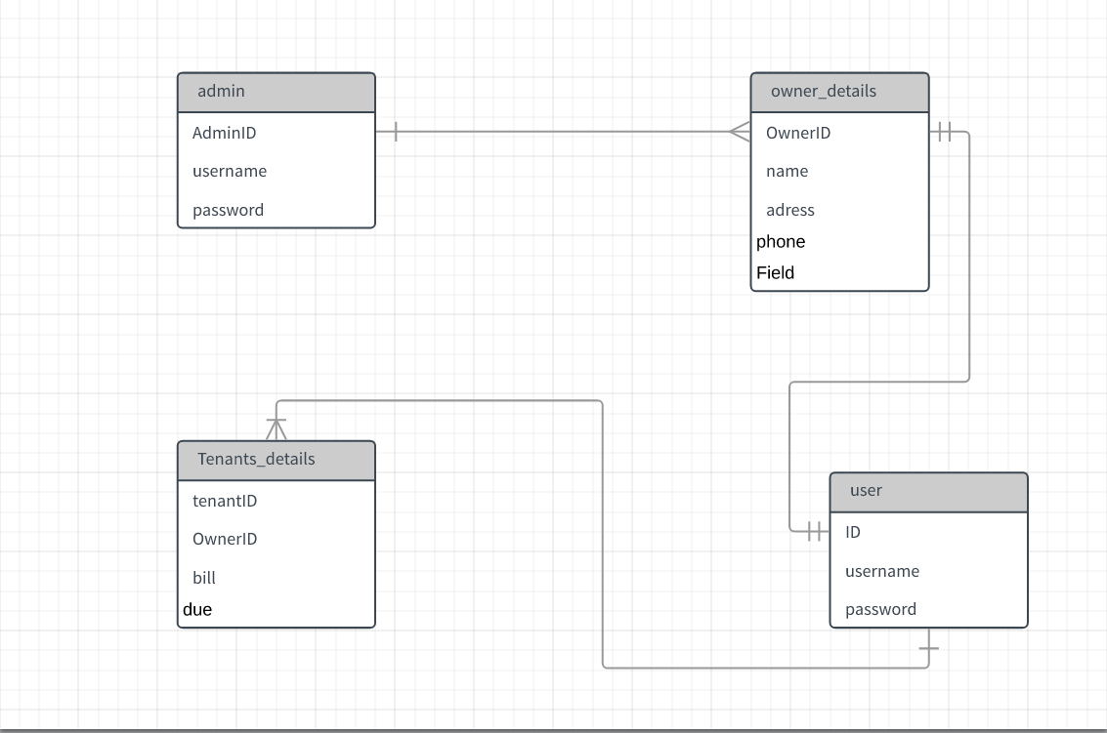

**SQL Query:**

-- Table structure for table `admin`

CREATE TABLE `admin` (

`admin_id` int(255) NOT NULL,

`admin_username` varchar(255) NOT NULL,

`admin_password` varchar(255) NOT NULL

) ENGINE=InnoDB DEFAULT CHARSET=latin1;

-- Dumping data for table `admin`

INSERT INTO `admin` (`admin_id`, `admin_username`, `admin_password`) VALUES

(1, 'aladin', 'admin123');

-- Table structure for table `owner_details`

CREATE TABLE `owner_details` (

`id` int(255) NOT NULL,

`name` varchar(255) NOT NULL,

`address` varchar(255) NOT NULL,

`phone` varchar(255) NOT NULL,

`area` varchar(255) NOT NULL,

`total_bill` int(255) NOT NULL

) ENGINE=InnoDB DEFAULT CHARSET=latin1;

-- Dumping data for table `owner_details`

INSERT INTO `owner_details` (`id`, `name`, `address`, `phone`, `area`, `total_bill`) VALUES

(1, 'Riajul', 'Narayngong', '0181726252', 'niltir', 10000),

(2, 'Moinul', 'Narayngong-28', '0191926252', 'bottola', 12344),

(3, 'Atik', 'dhaka-1212', '0171354565', 'mohakhali', 5000),

(4, 'Shuvo', 'dhaka-1000', '0177726252', 'puranbari', 12000),

(5, 'Marjan', 'Dhaka-1500', '0181726277', 'polton', 19000),

(6, 'Lalchan', 'Barishal-16', '0181725552', 'nodirpar', 6000);

-- Table structure for table `tenants_details`

CREATE TABLE `tenants_details` (

`owner_name` varchar(255) NOT NULL,

`tid` int(11) NOT NULL,

`name` varchar(255) NOT NULL,

`floor` varchar(5) NOT NULL,

`bill` varchar(123) NOT NULL,

`phone` varchar(255) NOT NULL,

`due` varchar(5) NOT NULL

) ENGINE=InnoDB DEFAULT CHARSET=latin1;

-- Dumping data for table `tenants_details`

INSERT INTO `tenants_details` (`owner_name`, `tid`, `name`, `floor`, `bill`, `phone`, `due`) VALUES

('Riajul', 1, 'Torun', '1st', '1234', '01234758', 'no'),

('Moinul', 3, 'billgates', '1st', '2348', '012349858', 'no'),

('Atik', 4, 'Trump', '1st', '12994', '012367758', 'yes'),

('Shuvo', 5, 'Tirban', '1st', '1834', '07534758', 'yes'),

('Marjan', 6, 'Morjina', '1st', '1734', '067834758', 'no'),

('Lalchan', 7, 'batman', '1st', '2334', '01734758', 'yes'),

('Riajul', 8, 'Torun', '2nd', '3234', '01734758', 'yes'),

('Moinul', 9, 'Bruce', '2nd', '2048', '015349858', 'yes'),

('Atik', 10, 'Lily', '2nd', '1994', '015367758', 'yes'),

('Shuvo', 11, 'Barry', '2nd', '5634', '015234758', 'yes'),

('Marjan', 12, 'Inuyasha', '2nd', '8934', '01834758', 'no'),

('Lalchan', 13, 'Antman', '2nd', '20034', '01739878', 'yes');

-- Table structure for table `users`

CREATE TABLE `users` (

`id` int(225) NOT NULL,

`username` varchar(225) NOT NULL,

`password` varchar(225) NOT NULL,

`adress` int(11) NOT NULL

) ENGINE=InnoDB DEFAULT CHARSET=latin1;

-- Dumping data for table `users`

INSERT INTO `users` (`id`, `username`, `password`, `adress`) VALUES

(1, 'ananta2', '1234', 0),

(2, 'rijvi2', '3456', 0),

(3, 'musa12', '23451', 0);

-- Indexes for dumped tables

-- Indexes for table `admin`

ALTER TABLE `admin`

ADD PRIMARY KEY (`admin_id`),

ADD UNIQUE KEY `admin_username` (`admin_username`);

--

-- Indexes for table `owner_details`

--

ALTER TABLE `owner_details`

ADD PRIMARY KEY (`id`);

--

-- Indexes for table `tenants_details`

--

ALTER TABLE `tenants_details`

ADD PRIMARY KEY (`tid`);

--

-- Indexes for table `users`

--

ALTER TABLE `users`

ADD PRIMARY KEY (`id`),

ADD UNIQUE KEY `username` (`username`);

--

-- AUTO_INCREMENT for dumped tables

--

--

-- AUTO_INCREMENT for table `admin`

--

ALTER TABLE `admin`

MODIFY `admin_id` int(255) NOT NULL AUTO_INCREMENT, AUTO_INCREMENT=2;

--

-- AUTO_INCREMENT for table `owner_details`

--

ALTER TABLE `owner_details`

MODIFY `id` int(255) NOT NULL AUTO_INCREMENT, AUTO_INCREMENT=7;

--

-- AUTO_INCREMENT for table `tenants_details`

--

ALTER TABLE `tenants_details`

MODIFY `tid` int(11) NOT NULL AUTO_INCREMENT, AUTO_INCREMENT=14;

--

-- AUTO_INCREMENT for table `users`

--

ALTER TABLE `users`

MODIFY `id` int(225) NOT NULL AUTO_INCREMENT, AUTO_INCREMENT=4;

COMMIT;

/*!40101 SET CHARACTER_SET_CLIENT=@OLD_CHARACTER_SET_CLIENT */;

/*!40101 SET CHARACTER_SET_RESULTS=@OLD_CHARACTER_SET_RESULTS */;

/*!40101 SET COLLATION_CONNECTION=@OLD_COLLATION_CONNECTION */;

**Project pictures**:

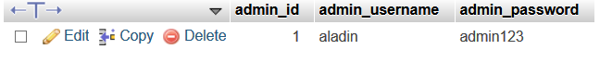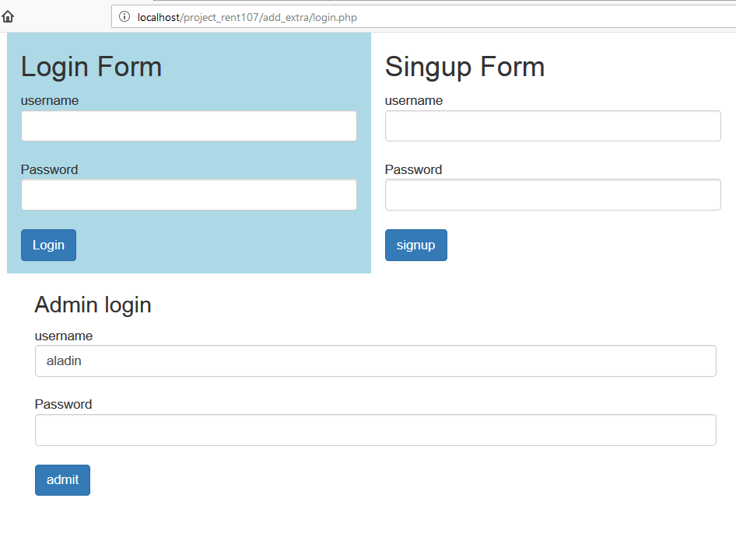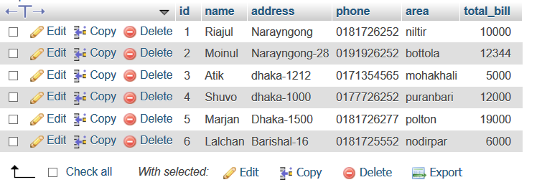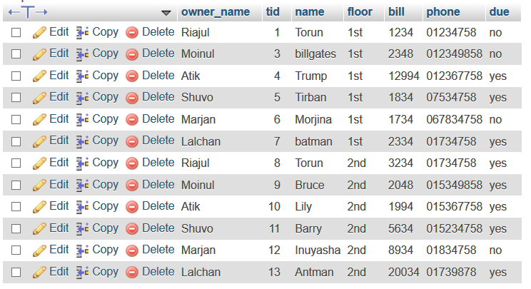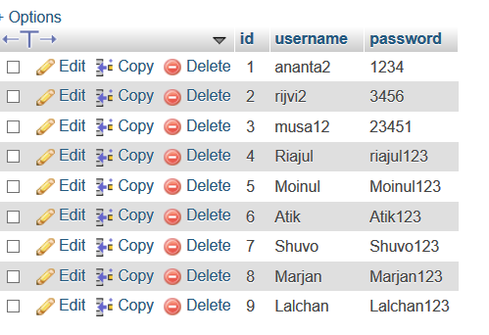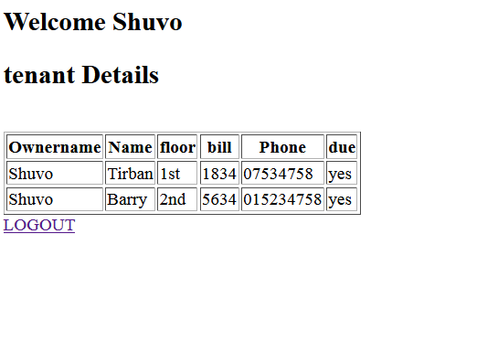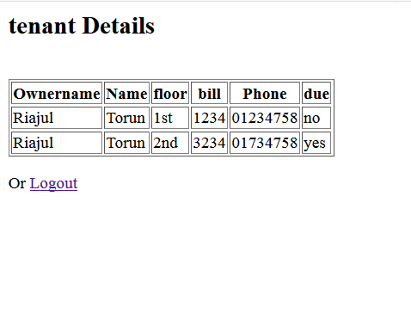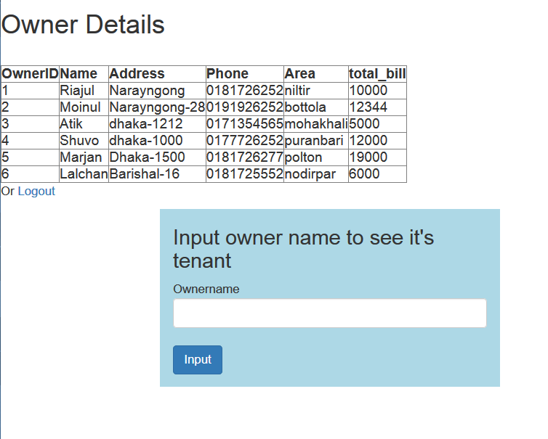

**Limitations:**

We could have done this project more efficiently and creatively. Due to some limitations we try to keep it as simple as possible. The limitations are :

* Inefficiency in php
* Inefficiency in python
* Limited time frame

**Conclusion:**

By doing this project we have gained proper knowledge about relational database management system. We have learnt html and php in some extend which has helped us to understand how RDBMS works and how we can use it to reduce redundant data and handle data more efficiently.